**SWAMI VIVEKANANDA UNIVERSITY**



A PROJECT ON PYTHON PROGRAMMING

Department

B.Tech- 3 rd Semester

Computer Science & Engineering

Subject:- It Workshop/Data Science Lab

Group- **A**

Project Group- **D**

**Indranil Paul**

* Submitted To: Submitted By:-

Indranil Paul

___________________ Roll No: 002-BCS-2022-174 Date: Ananya Roy

Roll No: 002-BCS-2022-022 Rohitashwa Pal Das Roll No: 002-BCS-2022-203

Sankhadeep Bhomwik

Roll No: 002-BCS-2022-020

Shivam Shaw

Roll No: 002-BCS-2022-086

INDEX

|  |  |  |
| --- | --- | --- |
| **Question No.** | **Question Name** | **Page**  **No.** |
| Q1. | Create a list and perform the following methods: 1) insert() 2) remove() 3) append() 4) len() 5) pop() 6) clear() |  |
| Q5. | Write python program to store data in list, tuple, set, dictionary and then try to print them. |  |
| Q11. | Write a Python program to check if a given string is a palindrome. |  |
| Q13. | Write a Python program to generate the Fibonacci series up to a given number of terms. |  |
| Q15. | Write a Python program to check if a given number is even or odd. |  |
| Q17. | Write a Python program to check if a given year is a leap year. |  |
| Q19. | Write a Python program to find the common elements between two lists. |  |
| Q23. | Write a python program to find compound interest. |  |

* Create a list and perform the following methods: 1) insert() 2) remove() 3) append() 4) len() 5) pop() 6) clear()

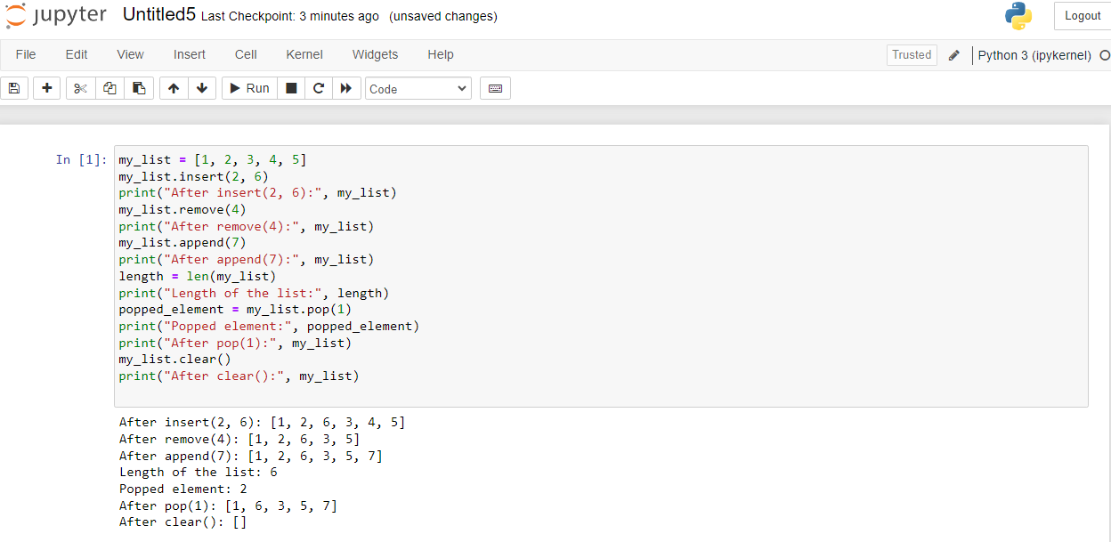

* Write python program to store data in list, tuple, set, dictionary and then try to print them.

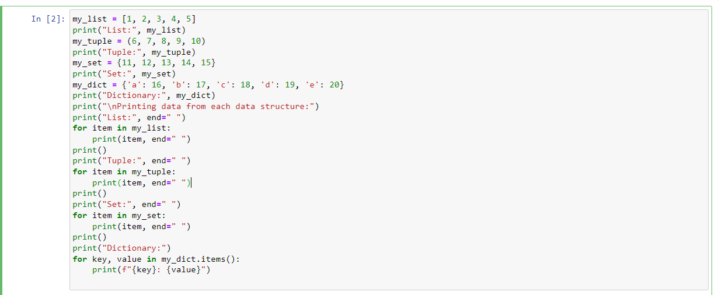

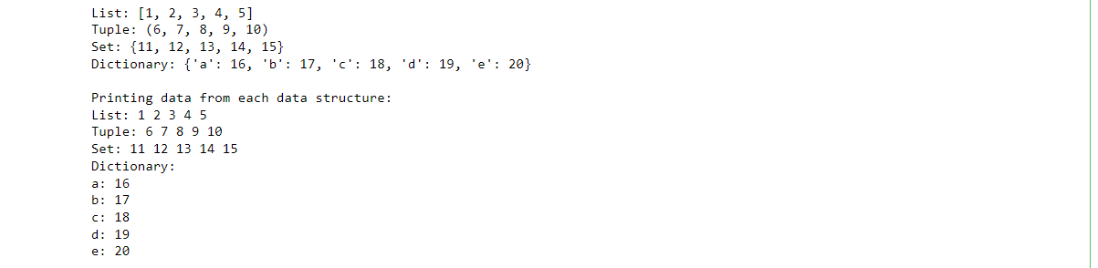

* Write a Python program to check if a given string is a palindrome.

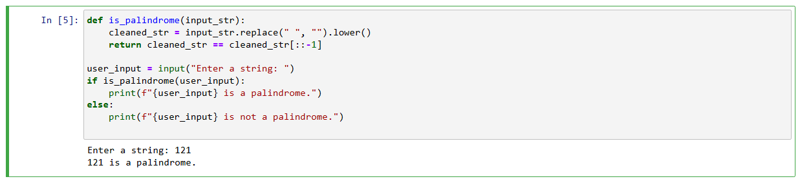

* Write a Python program to generate the Fibonacci series up to a given number of terms.

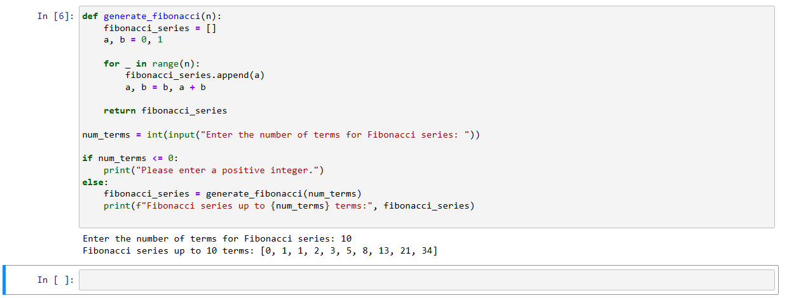

* Write a Python program to check if a given number is even or odd.

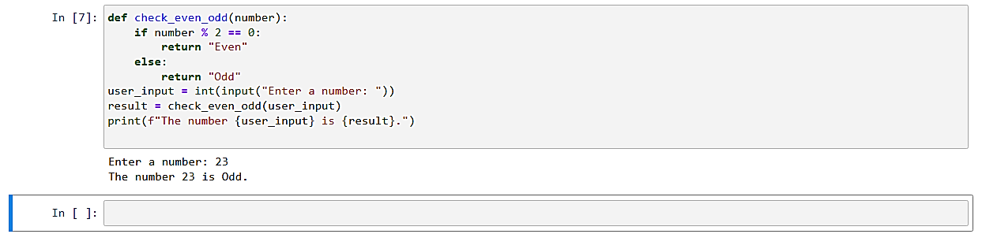

* Write a Python program to check if a given year is a leap year.

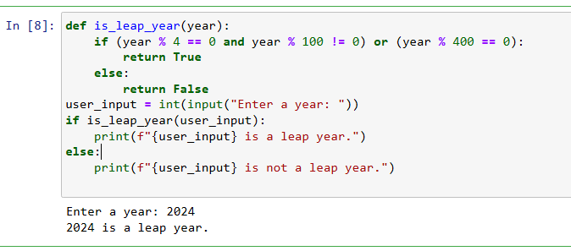

* Write a Python program to find the common elements between two lists.

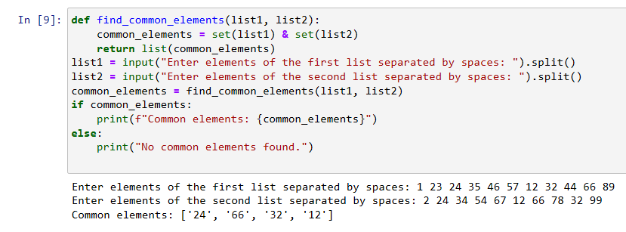

* Write a python program to find compound interest.

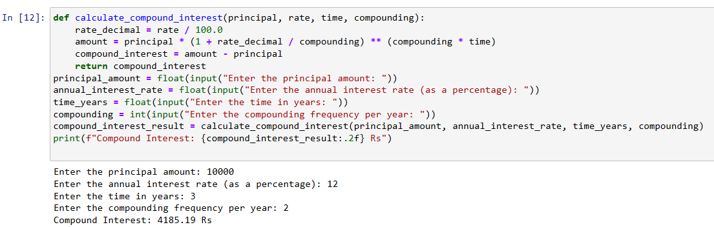

**ACKNOWLEDGEMENT**

I am thankful to all faculty members, providing their valuable time and guidance elaborating view of studying the project details and getting the right vision for its implementation.

I pay my immense gratitude to our respectful faculty of **SWAMI VIVEKANANDA UNIVERSITY** for his continuous and deliberate discussion on the topic and indeterminable burden taken by her in helping me throughout conducting the project.

Last but not the least I am grateful to all our friends for being our side always. Without their help and motivation it would have been impossible to complete this project.

* Submitted To: Submitted By:-

Indranil Paul

___________________ Roll No: 002-BCS-2022-174 Date: Ananya Roy

Roll No: 002-BCS-2022-022 Rohitashwa Pal Das Roll No: 002-BCS-2022-203

Sankhadeep Bhomwik

Roll No: 002-BCS-2022-020

Shivam shaw

Roll No: 002-BCS-2022-086